Student Performance Prediction System

Project Id: AIML-5

Name : Anirudh Rana
Class Roll Number: 32
University Roll Number : 2028641
Section and Group: U,G1

Name : Abhishek Negi
Class Roll Number: 3
University Roll Number : 2028377
Section and Group: U,G1

Name : Rahul Rawat
Class Roll Number : 19
University Roll Number : 2028470
Section and Group : U,G1

- Problem Description 3
- Architecture 4
- Models model 5
- Evaluation metrics used 6
- Preliminary Results and Visualizations 7
- References 8

- Problem Description
Design and develop an end-to-end machine learning classification system to predict loan default using customer banking data. The project should begin with exploratory data analysis (EDA) to understand data distributions, correlations, and patterns, followed by comprehensive data preprocessing including data cleaning, normalization, transformation, and dimensionality reduction using Principal Component Analysis (PCA) to handle high-dimensional data. The system should implement Support Vector Machine (SVM) classifiers using different kernel functions such as linear, polynomial, and radial basis function (RBF) and K-NN. The trained models must be evaluated and compared using standard classification performance metrics including precision, recall, F1-score, and ROC–AUC. The project should demonstrate a complete machine learning pipeline from raw data analysis to model evaluation, emphasizing best practices in preprocessing, model selection, and performance assessment.

- Architecture

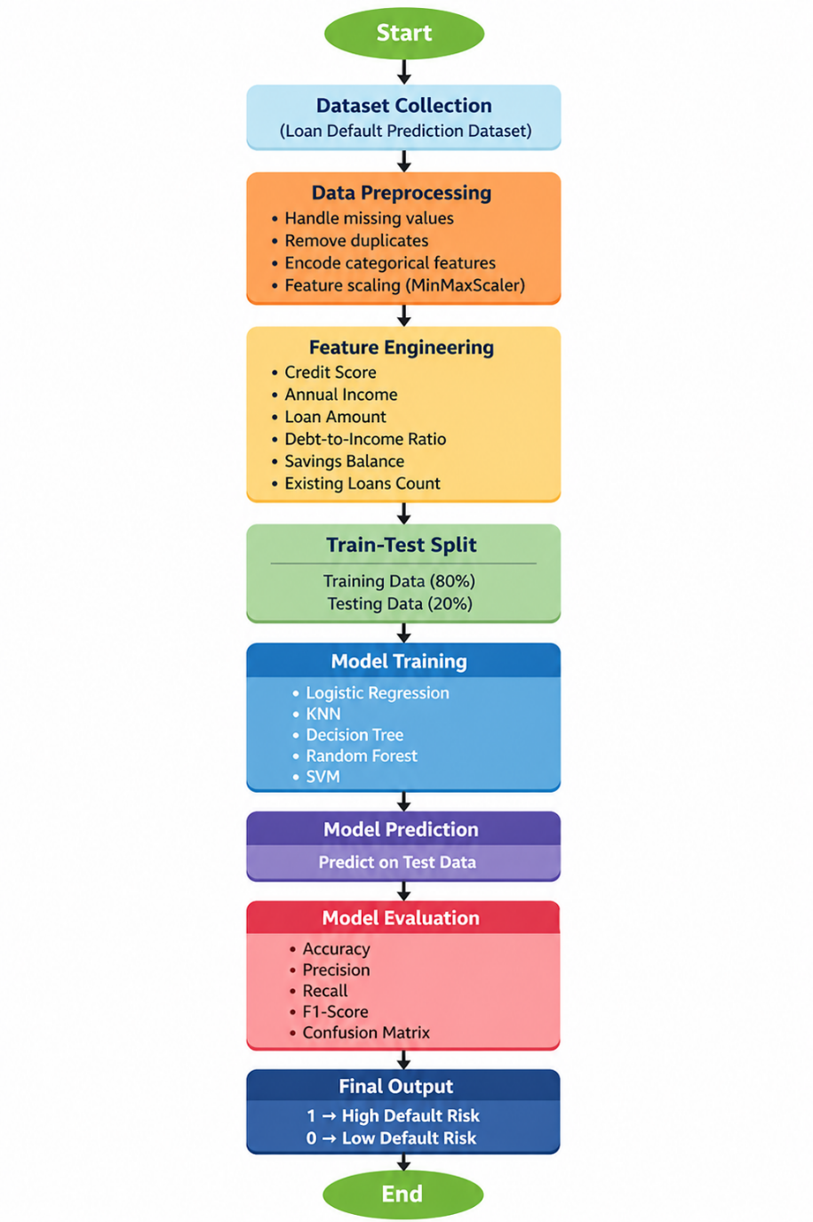
Fig.1 Sample flow diagram of Loan Default Prediction System.

- Models Used(Applied/ Planned) :

In this project, multiple machine learning models were
applied to predict loan default risk. Each model was evaluated
based on performance metrics to select the most suitable one.

I. Logistic Regression
Logistic Regression is a supervised learning algorithm used
for classification problems. It predicts the probability of a
binary outcome (default or not default) using a sigmoid
function. It is simple, efficient, and works well for linearly
separable data.

II. K-Nearest Neighbors (KNN)
KNN is a non-parametric algorithm that classifies data points
based on the majority class of their nearest neighbors. It is
easy to implement and useful for pattern recognition but can be computationally expensive for large datasets.

III. Decision Tree
Decision Tree is a tree-based model that splits data into
branches based on feature values. It is easy to interpret and
helps in understanding decision-making logic. It can handle
both numerical and categorical data.

IV. Random Forest
Random Forest is an ensemble learning method that uses
multiple decision trees to improve accuracy and reduce
overfitting. It provides better performance compared to a
single decision tree.

V. Support Vector Machine (SVM)
SVM is a powerful classification algorithm that finds the
optimal hyperplane to separate classes. It works well for high-
dimensional data and provides good accuracy.

- Evaluation metrics used :

I. Accuracy
Accuracy measures the overall correctness of the model. It is
the ratio of correctly predicted instances to the total number
of instances.

II. Precision
Precision measures how many of the predicted positive cases
are actually correct. It is important when minimizing false
positives is required.

III. Recall
Recall measures how many actual positive cases are correctly
identified by the model. It is important when detecting all
possible positive cases.

IV. F1-Score
F1-Score is the harmonic mean of precision and recall. It
provides a balance between precision and recall and is useful
for imbalanced datasets.

V. Confusion Matrix
A confusion matrix is a table that shows the number of correct
and incorrect predictions made by the model, categorized into
true positives, true negatives, false positives, and false
negatives.

5. Preliminary Results and Visualizations

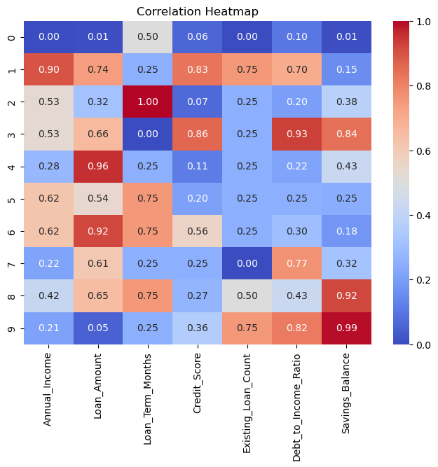

Fig.2 Heatmap showing correlation of first 10 rows.

 | Model | Accuracy (%) | Precision | Recall | F1-Score
0 | Decision Tree | 86.0 | 0.901047 | 0.860 | 0.881857
1 | Random Forest | 83.5 | 0.859508 | 0.835 | 0.865306
2 | SVM | 79.5 | 0.796599 | 0.795 | 0.844106
3 | KNN | 73.5 | 0.725889 | 0.735 | 0.809353
6. References:
Books:
- Let Us Python – Yashavant Kanetkar

Online Resources:
  - GeeksforGeeks – https://www.geeksforgeeks.org/
  - TutorialsPoint – https://www.tutorialspoint.com/cprogramming/index.htm
  - Stack Overflow – https://stackoverflow.com

